18.3.1 Editors - Drivers Editor - Sidebar - F-Curve Tab
F-Curve Tab - Active F-Curve Panel 1
Channel Name 1
RNA Path 1
RNA Array Index 1
Display Color 1
Handle Smoothing 2
None 2
Continuous Acceleration 2
F-Curve Tab - Active Keyframe Panel 2
Interpolation 2
Key Frame 2
Value 2
Left Handle Type / Right Handle Type 2
Free 2
Aligned 2
Vector 3
Automatic 3
Auto Clamped 3
Frame 3
Value 3

F-Curve Tab - Active F-Curve Panel
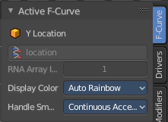
This panel displays the properties for the active F-Curve.

Note that you need to have a channel selected to reveal the tabs.

Channel Name
The name of the currently active F-Curve channel.

RNA Path
RNA Path to property. This is a read only information.

RNA Array Index
The RNA Array Index to the specific property affected by the F-Curve if applicable. This is a read only information.

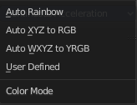
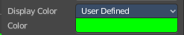
Display Color
With what colors to display the curves. User defined allows you to choose a custom color for the curve. A color field appears. The other methods works random.

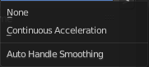
Handle Smoothing
Select the method to compute automatic Bezier Handles.

None
Only directly adjacent key values are used when computing the handles. Vector handles points directly at the adjacent keyframes.

Continuous Acceleration
Also keyframes behind the next or previous keyframe gets used for calculation. Which results in a smoother curve.

F-Curve Tab - Active Keyframe Panel

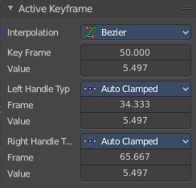

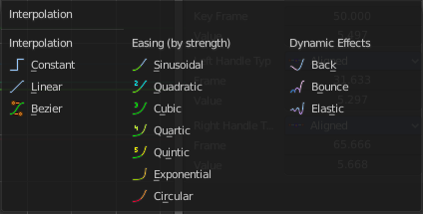
Interpolation
Set the interpolation type for this keyframe.

Key Frame
The current position of this keyframe.

Value
The Y value of this keyframe.

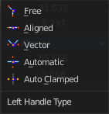
Left Handle Type / Right Handle Type
Set the handle type. The handles of a keyframe can be independent. Some constellations just works with some other constellations.

Free
Move and adjust the handles independently.

Aligned
With the left handler the right handler moves too.

Vector
Creates a curve with straight lines.

Automatic
Creates a smooth curve.

Auto Clamped
Creates a smooth curve that only changes the direction at other curve points. It is clamped to prevent overshoots in the curve shape.

Frame
The current frame of this handle.

Value
The current Y position of this handle.

